Name : Sakthi Manoj R Reg No : 192324236
PROGRAM 5
Create and Manipulate Factor Variables
Aim:
To create and manipulate factor variables using categorical values and a random LETTERS sample.
Procedure:
Step 1: Open RStudio or R console on your computer.
Step 2: Create a character vector containing categorical values such as height levels.
Step 3: Convert the character vector into a factor to represent it as categorical data.
Step 4: Display the factor to observe the categories and their assigned levels.
Step 5: Set a random seed value to ensure that the random sampling results remain the same each time you run the program.
Step 6: Randomly generate a sample of letters from A to E using the sample function.
Step 7: Convert the generated letters into a factor to represent them as categorical variables.
Step 8: Print the factor to view the sampled categories and their assigned levels.
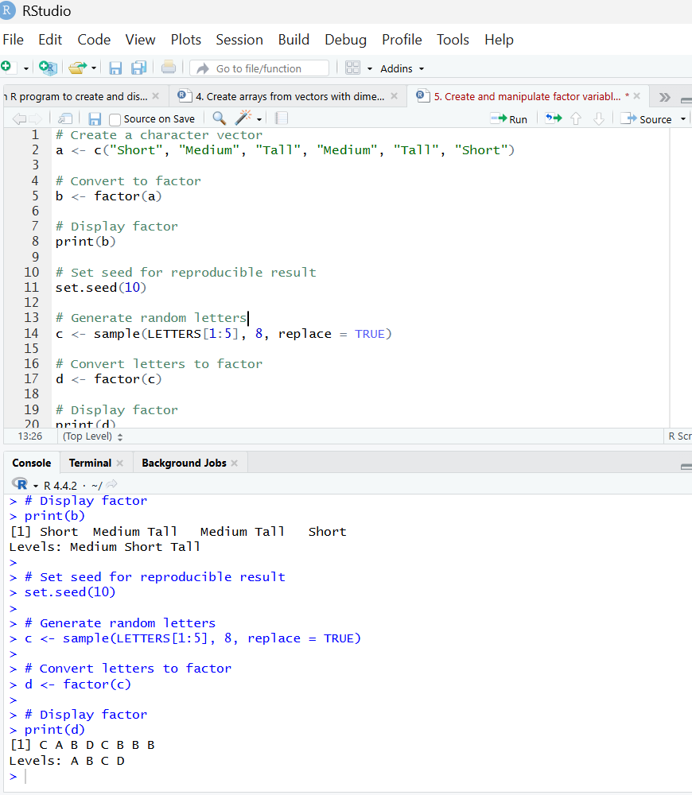
Result:
Hence the output is verified successfully.

